Job-Ready Dev Plan — Business Requirements Document
Nov 6, 2026 · @shreeram arun kaudare

Overview
We are building a web app that takes a complete beginner to job-ready full stack developer through a day-wise plan where real learning cannot be faked.
Problem. In the AI era, many learners build websites and apps by prompting AI. They finish projects but cannot write, debug or explain code on their own, and they fail interviews.
Vision. Every day has one task, one proof of work, and one check that the learner actually understood it. At the end, the learner has strong coding skills, two solid projects, and interview readiness.
Selling point.
- Day-wise plan, not a roadmap. A roadmap says what to learn. We say what to do today.
- Learning that can't be faked. Commits as proof, explain-back checks on the learner's own code, and debug labs make AI shortcuts pointless.
- Honest outcomes. Realistic timelines and salary expectations, no overpromising.
Pricing. Free for now. Mentors and paid options may come later.

Target users and rollout
The first user is the founder; students come only after the plan proves practical.
Phase | Who | What happens
1. Self-test | Founder | Follow the day-wise plan from a doc or notebook. Claude writes content in 1–2 week batches.
2. Build | Founder | Build the platform itself as Capstone 1 in month 4–5, using the skills learned.
3. Launch | Students and job aspirants | Open the platform free once the content and format are proven.
4. Grow | Students | Consider per-student mentors and paid options.
Target students: complete beginners, college students (especially 3rd and 4th year), graduates looking for a job, and working professionals switching careers.

Curriculum, tracks and tech stack
The curriculum runs in 6 phases, with web skills and DSA learned in parallel and two capstones at the end.
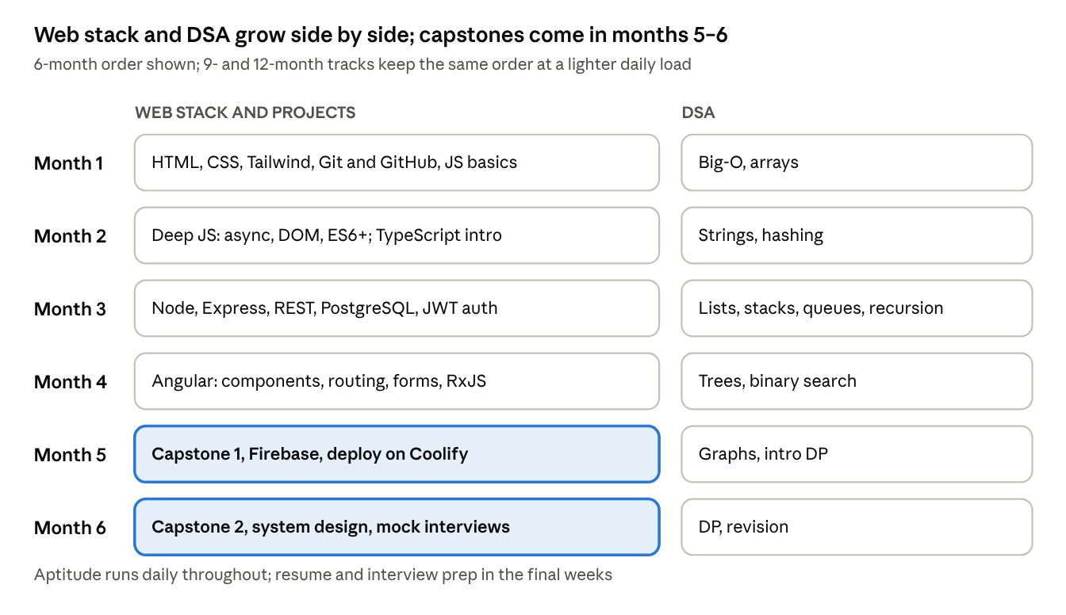
curriculum roadmap · 6 phases
Each phase is broken into daily tasks. Longer tracks keep the same content and order, with less work per day.

Tracks
Daily time | Recommended track | Realistic time to job-ready | Google-level
Full-time, 6–8 hrs/day | 6 months | 6–7 months | 12–18 months
Student or working, 3–4 hrs/day | 9 months (default) | 9–12 months | 18–24 months
Casual, 1–2 hrs/day | 12 months | 18+ months | 3+ years

Daily structure (6-month track)
- 2 hours build, 1 hour DSA (1–2 problems), 20 minutes aptitude, 10 minutes revision.
- Hardest work (build, DSA) in the sharpest 2–3 hours of the day.
- One rest day a week.

Tech stack taught
- Core: HTML, CSS, Tailwind CSS, JavaScript, TypeScript, Node.js, Express.js, Angular, PostgreSQL, Git, GitHub, Coolify.
- Optional bonus tracks: Forgejo self-hosting, advanced Firebase.
- Alongside: DSA (about 300 problems by pattern) and aptitude (quant, logic, verbal).

Learning-integrity features
These features make cheating pointless rather than impossible; "no AI" cannot be enforced, so the design relies on proof and checks.
Feature | How it works
Build-from-scratch tasks | Each topic has a task with starter files and acceptance criteria. No copy-paste solutions.
Hint ladder | 3 hints per task, from a small nudge to a near-answer.
Proof of work | Every task needs a GitHub commit link. Streaks count only real commits.
Explain-back check | 3 questions about the learner's own code, graded by AI.
Predict-the-output quizzes | JS, SQL and async behaviour.
Debug labs | Deliberately broken code to fix.
AI-allowed levels | Weeks 1–8: no AI. After that: AI only for review and explanation, never for writing code.

Daily task template
Every day in the plan follows the same structure:
- Goal: one clear outcome for the day
- Learn: concepts, with a free resource (MDN, javascript.info, etc.)
- Build task: what to make, with acceptance criteria
- Hint ladder: 3 hints
- Proof: what the commit should contain
- Explain-back: 3 questions answered in the learner's own words
- DSA: 1–2 problems by pattern
- Aptitude: one topic, 5–10 questions
- Revision: what to review from earlier days

Onboarding and settings
Onboarding asks 7 questions, one per screen, and every answer can be changed later in Settings.
# | Question | Options | What it changes
1 | Current level | Total beginner / Know a little / Can build simple things (+ optional 5-minute quiz) | Starting point, skip-topic offers
2 | Hours per day (normal day, not best day) | 1–2 / 3–4 / 5–6 / 7+ | Daily load
3 | Track | 6 / 9 / 12 months (9 is default) | Plan length. Warns if hours don't fit the track.
4 | Background | College student (year) / Graduate / Working professional | Aptitude weight, weekend-heavy schedule for working people
5 | Start date | Today / Tomorrow / Monday | Day 1 date
6 | Rest day | Any day of the week | Weekly day off, built into the plan
7 | Goal | Any job / Good product company / Top product company | DSA weight
The last screen shows a personal summary, for example: "9 months, 3–4 hrs/day, Sunday off, starts Monday 9 Nov. Expected finish: early August 2027."

Settings rules
- Completed days always stay completed. Nothing is lost.
- Changing hours or track recalculates only the remaining days.
- Before saving, show the effect on the finish date.
- Track changes are limited to once every 2 weeks.

Plan rules
A missed day pushes the plan forward by default, and a topic can be skipped only by passing a test.

Missed days
- Each missed day moves all remaining days forward by one, and the finish date updates.
- The dashboard shows it gently ("Finish date moved to 12 Aug 2027"). Never a "you failed" message.
- After 5+ missed days in a row, show a "welcome back" screen offering a short revision day first.

Skip a topic (test-out)
- Each module has a test: 10 predict-the-output or concept questions plus one small build task.
- Pass mark about 80%. Passing marks the module "skipped (tested)" and shortens the plan.
- Failing shows the weak parts and offers a shorter module covering only those.
- Retry allowed after 24 hours.
Never skippable: explain-back checks on capstone projects, DSA, and Git workflow basics.

AI grading of explain-back
AI grades explain-back answers: lenient on language, strict on understanding. Hinglish and grammar mistakes never cost marks; wrong concepts do.
What is checked
- Correctness: is the explanation technically right?
- Ownership: does it refer to the learner's own code (their variable names and choices), or is it a generic answer?
- Depth: does it explain why, not only what?
Result levels
Level | Meaning | Next step
Clear | Understands it | Day complete
Almost | Mostly right, one gap | AI asks one follow-up question; a good answer upgrades to Clear
Not yet | Key misunderstanding | AI explains the gap; day stays open for a retry
Copy-paste handling. The AI reads the learner's actual commit and asks about specific lines ("Line 14 uses a for loop. Why not forEach?"). A mismatch gets "Almost" plus a follow-up, never an accusation.
Limits. 3 attempts per task per day. After 3 "Not yet" results, unlock the last hint and a short explanation, then move on. Weak areas come back on revision days.
Future: a per-student mentor may join or replace AI grading.

Projects, content and outcomes

Capstone projects
Project | Stack | Must include
Capstone 1: this platform (or Job Application Tracker / Team Task Board) | Angular, Tailwind, Express, PostgreSQL, JWT auth, deployed on Coolify | Tests, README, architecture diagram, demo video
Capstone 2: real-time app (chat, booking or collaboration) | Firebase + Express | CI, role-based access, Forgejo mirror, README, diagram, demo video

Other modules
- DSA tracker: about 300 curated problems by pattern.
- Aptitude: quant, logic and verbal, with timed tests.
- Interview prep: HR questions, project walkthroughs, system design basics, mock interview checklist.
- Dashboard: progress, streaks, weak-topic analytics, portfolio and resume builder.

Content plan
- Claude writes all content: daily tasks, quizzes, debug labs and explain-back questions.
- Written in batches of 1–2 weeks ahead of the learner, so later weeks can be adjusted.
- The founder keeps a progress log (day, what was done, where it was hard) and shares it for the next batch.
- Content is the main work: 150+ tasks, quizzes and labs.

Expected outcomes (India, approximate)
Where you land | Typical fresher package
Small startup or service company | ₹3–5 LPA
Mid-size product company or good startup | ₹6–12 LPA
Top product companies (Google, Microsoft, Amazon) | ₹20–45+ LPA
Most learners who finish seriously land in the first two rows within 2–4 months of applying. The top row usually needs 12–24 months of steady DSA and often a first job first. Ranges change yearly; check current listings before relying on them.

Decisions, risks and next steps

Decisions so far
Topic | Decision
Product format | Day-wise plan, not just a roadmap
First user | Founder; open to students once proven practical
Learning integrity | Commits as proof, explain-back, debug labs, AI-allowed levels
Grading | AI grading now; per-student mentors later
Content | Claude writes all content in 1–2 week batches
Pricing | Free for now
Tracks | 6, 9 and 12 months; 9 is default
Onboarding | 7 questions, all changeable in Settings
Missed days | Push forward by default
Skip topic | Allowed through a test-out; some parts mandatory
Grading style | Lenient on language, strict on understanding; Clear / Almost / Not yet
Build timing | No app now; build it as Capstone 1 in month 4–5
Scope cuts | Forgejo and part of Firebase become optional bonus tracks

Risks
- Dropout: the full stack plus DSA plus aptitude is heavy. Mitigated by honest tracks, rest days and push-forward.
- Content effort: 150+ quality tasks is the main work, more than the app.
- AI cost: AI grading is cheap for one user but grows with many free students.
- Overpromising: Google-level in 6 months from zero is not realistic; the app must say so.

Open questions
- Founder's own answers to the onboarding questions (level, hours, track, background).
- How the dashboard and streaks should work.
- What the daily task screen looks like.

Next steps
- ☐ Founder answers the onboarding questions
- ☐ Claude writes Week 1 content
- ☐ Founder starts Day 1 and keeps a progress log
- ☐ Discuss dashboard, streaks and day screen design

